W-18
YEAR 10 SCIENCE (IEP)
PHYSICAL SCIENCE
TOPIC TEST
Name: Mark: $\frac{}{\text{18}}$

Part 1: Multiple Choice
MULTIPLE CHOICE ANSWERS
1
2
3
4
5
6

Write your choice for each question in the table below.

1. The crumple zone of a car is designed to:

(a) allow the vehicle and passengers to stop more slowly.
(b) decrease the time before the car comes to a stop after a collision.
(c) allow the chassis to bend.
(d) create a reaction force that equals the action force.

2. Speed is a measure of the rate:

(a) at which distance is covered.
(b) at which speed increases.
(c) of change in force.
(d) of change in acceleration.

3. The tendency of an object to try to stay still when a force is applied to it is called:

(a) inertia.
(b) weight.
(c) friction.
(d) work.

4. Newton’s law, known as the law of inertia, is:

(a) his first law.
(b) his second law.
(c) his third law.
(d) none of the above.

5. The force of gravity acting on an object is called:

(a) inertia.
(b) weight.
(c) friction.
(d) work.

6. In the diagram below, the arrows show the size and direction of two force arrows acting on the bike.

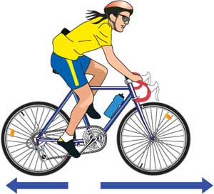

Which of the following describes the effect of the pair of forces on the bike?

(a) The bike will slow down.
(b) The force forwards is bigger that the force backwards.
(c) The bike will remain stationary.
(d) The two forces are equal.

Part 2: Short Answer

1. The map below shows Broome and Alice Springs. Use the map (look at it carefully) and its scale to work out the following.

(a) The distance between Broome Airport and Alice Springs airport on the road
(marked in blue). (1 mark)

(b) The distance between Broome Airport and Alice Springs airport on the road
(marked in grey). (1 mark)

(c) What is the scale on the map - how many kilometres does it show? (1 mark)

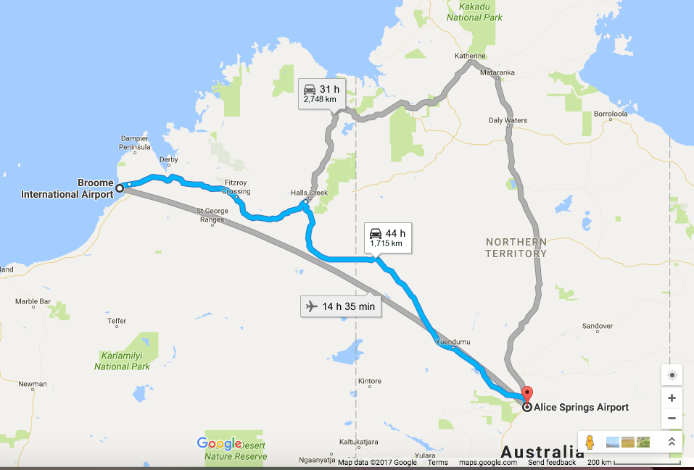
2. Complete the following table on speed calculations. Use the triangle to help you.
(3 marks)
sp
d
t

Distance travelled | Time taken | Average speed
490 m | 35 s
195 m | 12 s
1600 m | 240

3. What happens to a ball placed on the middle of the back seat of a car in the following situations.

(a) The car brakes suddenly. (1 mark)

(b) The car turns right. (1 mark)

(c) The car accelerates. (1 mark)

4. On Earth, you have a particular weight value measured in Newtons.

e.g. A person of 60 kg has a weight of about 600 N.

If you go to the Moon, gravity is different and you will have a different weight.

CIRCLE THE BEST ANSWER BELOW.

• Your weight on the Moon would:

(a) increase.

(b) decrease.

(c) stay the same. (1 mark)

5. In the diagram below, calculate the resultant force that is acting and its direction.

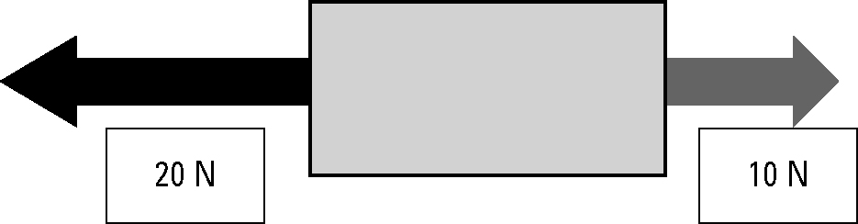

Resultant force: N

Direction: (2 marks)

